Earthquake!
You feel the rumble beneath your feet. Books begin to fall off the shelf. The room is shaking. As quickly as it started, it is over.
Whether it is a barely noticeable tremor or a 7.0-building-destroying-doozy, earthquakes are pretty scary. What causes the earth to tremble? How are they able to cause so much damage in such a short period of time?

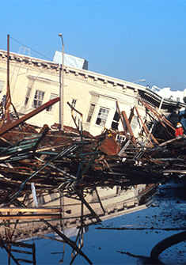

Organize What You Learn
Use this graphic organizer (SEE ATTACHMENT), which is in an outline format, to compare ideas about seismic waves. Fill in the details about the topics under each heading.

Seismic Waves Are Mechanical Waves
Before you learn more about earthquakes and seismic waves, review the different features of mechanical waves.

Galleria

Medium


Photograph of the sky and a dried up river bed

All mechanical waves require a medium to travel through. A medium can be a solid, a liquid, or a gas.

Transverse Waves


A diagram of blue does in a wave pattern with red dots to show a transverse wave

The energy in transverse waves travels perpendicular to the motion of the wave.

Longitudinal Waves


A diagram of blue dots in lines spaced close and far with a line of red dots close together to show a longitudinal wave.

Both the energy and wave motion travel in the same direction in longitudinal waves.

Amplitude

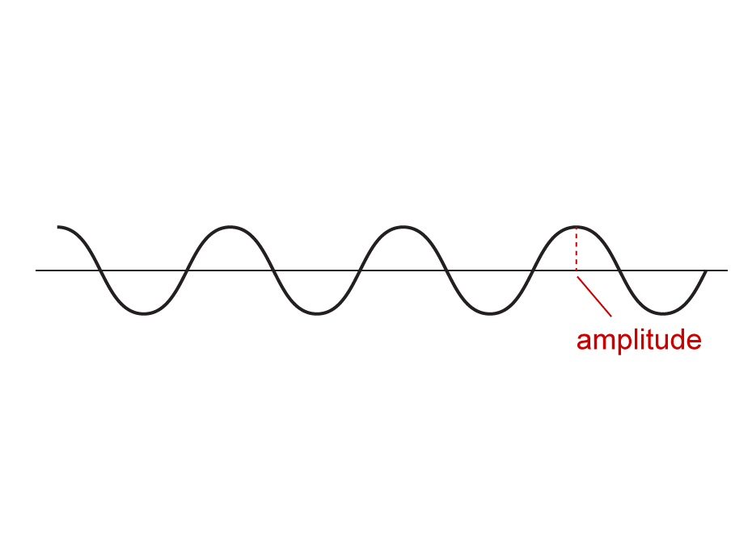
A wave diagram shows a line with a series of curves above and below a midline. The distance between one highpoint and the midline is labeled amplitude.

The intensity of a mechanical wave is determined by the amplitude. Larger amplitudes have higher intensities.

P and S Waves
When an earthquake occurs, its energy moves through the earth as seismic waves.
The primary wave (a P wave) is a wave that travels very fast and is the first wave to arrive at a seismograph station after a seismic event. These waves are longitudinal in nature, meaning their disturbance moves parallel to the direction of their motion. They are also able to travel through any type of medium (solid, liquid, and air).
The secondary wave (the S wave) is a wave that travels slower than the primary wave. These waves, unlike the primary wave, are transverse in nature, which means their disturbance is perpendicular to the wave motion. Unlike the primary wave, the secondary wave is only able to travel through solid earth.

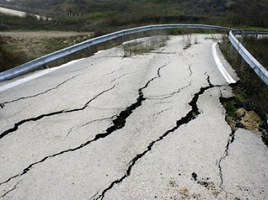

Earthquake Creation
An earthquake is felt by everyone near the point right above where the earthquake occurs. This point is referred to as the epicenter. Earthquakes release energy that travels in all directions away from the epicenter. As the energy spreads out, it becomes less intense. This explains why the earthquake is more intense at the epicenter and less intense at locations farther away from the epicenter.

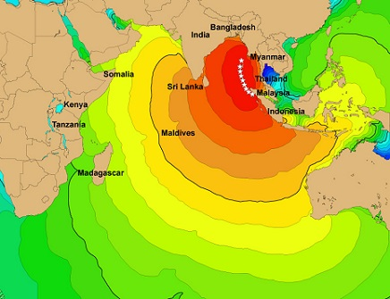

Using Seismic Waves
Seismic waves are created during an earthquake or a large explosion. The primary and secondary waves created by these events travel around, as well as through, the Earth. Whenever a wave encounters a new medium, it will be partially reflected back. A wave that travels towards the center of the Earth will be reflected whenever it encounters a new layer. After a seismic event, seismograph stations often receive several reflected waves proving that the Earth has internal layers that change as you go deeper below the Earth’s crust. The time it takes for the reflected wave to reach the seismograph station allows scientists to determine how far below the Earth’s surface each layer is, based on the speed of the wave.
Because P waves can travel through all mediums but S waves can only travel through solids, scientists can analyze the P and S waves to determine where liquid layers occur inside the Earth.

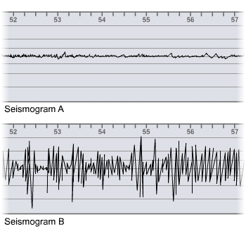

Assignment: Seismic Waves Research Current Events Exploration
For this lesson's graded assignment, you will do research on the Internet to learn more about the role seismic waves play in earthquakes and tsunamis. Your essay will address one of the following questions:
- How does an underwater earthquake cause a tsunami?
- Why do some earthquakes cause more damage than others?
Here is a website and some keyword search terms to help you get started.
USGS Earthquakes
Keywords search terms: earthquake formation, P wave, S wave, tsunami, earthquake travel, analyzing earthquakes
Your essay should do the following things:
- discuss how the different types of waves are formed and how the waves travel
- explain how scientists use the waves to track and analyze earthquakes
- cover recent events involving earthquakes and/or tsunamis that illustrate the points made in your explanation
Your essay should be about 350-450 words, which is 1-1.5 typed pages, double-spaced, using 12 pt. font.

